I have a report server Called: https://appserver3/ReportServer and there are some deployed reports with one DataSource called: ReportsDS and all these reports on the server are opening very good by Report Manager: https://appserver3/Reports.

Also all reports can be viewed in SharePoint using ReportViewer web part.

But when we call these reports in ASP Web Site page or SharePoint Site definition aspx page: it gives error The Request failed with http status 401: unauthorized

The control is:
Microsoft.Reporting.WebForms.ReportViewer and also I send the DataSource Credential "SQL Authentication" before everything;
Inline Code is:

<%@ Register Assembly="Microsoft.ReportViewer.WebForms, Version=8.0.0.0, Culture=neutral, PublicKeyToken=b03f5f7f11d50a3a"
Namespace="Microsoft.Reporting.WebForms" TagPrefix="rsweb" %>

<rsweb:ReportViewer ID=" ReportViewer1" runat="server" Font-Names="Verdana" style="width: 100%"
Font-Size="9pt" BorderStyle="Solid" BorderWidth="1px" ShowParameterPrompts="False" Visible="True" AsyncRendering="False" SizeToReportContent="True" ShowCredentialPrompts="False">
</rsweb:ReportViewer>

the complete code in code behind will be
protected ReportViewer ReportViewer1;

protected void Page_Load(object sender, EventArgs e)
{
ReportViewer1.ProcessingMode = ProcessingMode.Remote;

ReportViewer1.ServerReport.ReportPath = "/ArmyReports/Report100"

ReportViewer1.ServerReport.ReportServerUrl = new Uri("https://appserver3/ReportServer")

ReportViewer1.ServerReport.ReportServerCredentials = new ReportServerCredentials(“kadaa\mossadmin”,”password”, “Kadaa”);

DataSourceCredentials dc = new DataSourceCredentials();
dc.Name = "ReportsDS"; //The name of report server project datasource
dc.UserId = "sa"; // sql server authentication user
dc.Password = "password"; // password of sql server authentication user, the both are working good when log in to sql server
ReportViewer1.ServerReport.SetDataSourceCredentials(new DataSourceCredentials[] { dc }); // this method gives error says: The Request failed with http status 401: unauthorized. in the status box it says: System.Net.WebExceptionsStatus.ProtocolError

ReportViewer1.ServerReport.Refresh(); also gives this error but in page

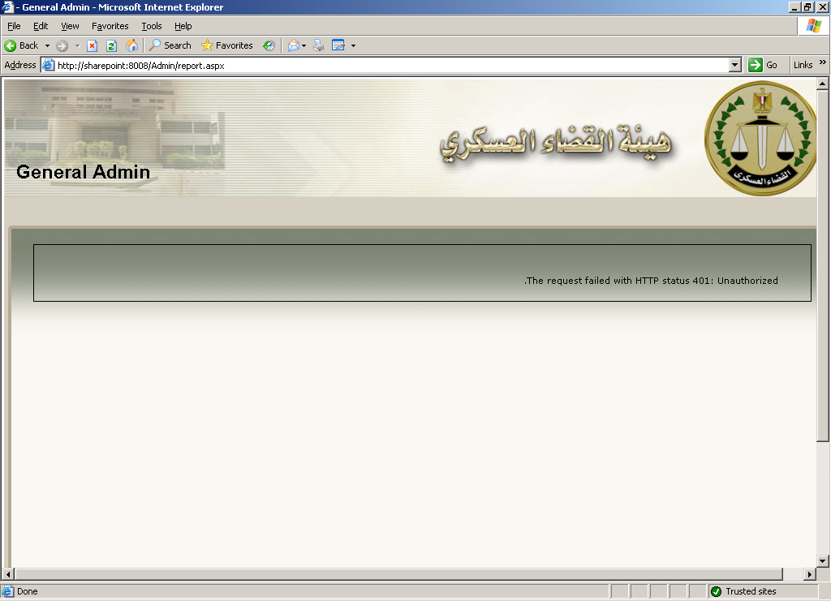

Note That:
ReportServerCredentials is a class, the following is its code:

using System;
using System.Data;
using System.Configuration;
using System.Web;
using System.Web.Security;
using System.Web.UI;
using System.Web.UI.WebControls;
using System.Web.UI.WebControls.WebParts;
using System.Web.UI.HtmlControls;
using System.Net;
using System.Security.Principal;
using Microsoft.Reporting.WebForms;

[Serializable]
public class ReportServerCredentials : IReportServerCredentials
{
private string _userName;
private string _password;
private string _domain;

public ReportServerCredentials(string userName, string password, string domain)
{
_userName = userName;
_password = password;
_domain = domain;
}

public WindowsIdentity ImpersonationUser
{
get
{
// Use default identity.
return null;
}
}

public ICredentials NetworkCredentials
{
get
{
// Use default identity.
return new NetworkCredential(_userName, _password, _domain);
}
}

public bool GetFormsCredentials(out Cookie authCookie, out string user, out string password, out string authority)
{
// Do not use forms credentials to authenticate.
authCookie = null;
user = password = authority = null;
return false;
}
}

This is the Datasource Settings in the buisiness intellegant Report Server Project : and also the connection string Test was succeed

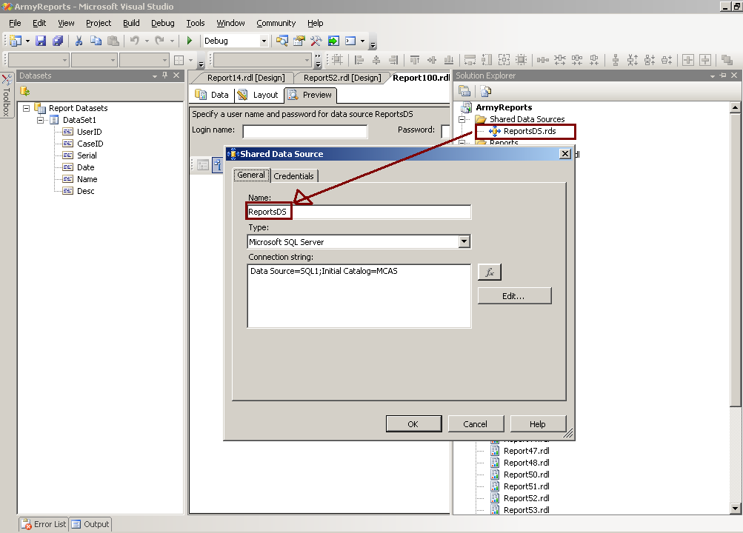

And this is the Credential Tab:

